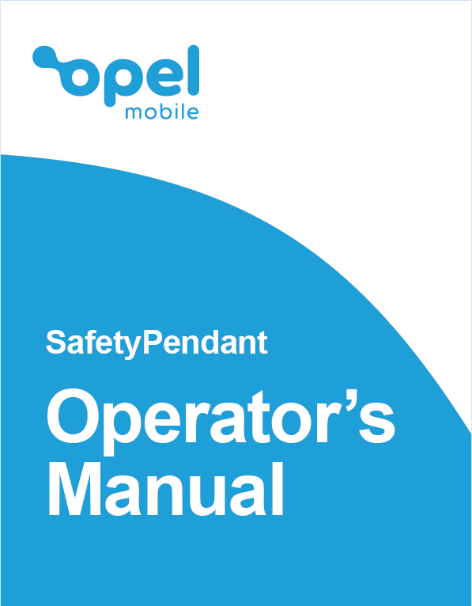

Table of Contents

Safety Information 4
How to handle and preserve your device? 5
Safety recommendations for accessories 6
Usage conditions and restrictions 7
Overview of the Safety Pendant 9
Quick Setup Guide 10
The AIBEILE App 13
Downloading AIBEILE App 13
Registering and pairing the Safety Pendant 14
Pairing additional devices 19
Low Battery Alert 25
Safety pendant Settings 26
Edit User Profile 27
Phonebook/Whitelist Numbers 27
Medicine Reminders 29
Geofence 31
Emergency Numbers 33
Fall Detector 34
Notifications 36
AIBEILE Account 37
The Safety Pendant 38
Powering On and Off 38
Charging the Safety Pendant 38
Answering an incoming call 39
Ending a call 39
Activating the SOS Alert 40
Stopping SOS Alert 40
Fall Detection Alert 40
Stopping Fall Detection Alert 41
Low Battery Alert 41
Using the Safety Pendant in water 41
Using the included accessories 42
Troubleshooting and Support 43

Safety Information
Welcome to Opel Mobile and thanks for purchasing our products. For the best performance, we recommend you read this manual carefully, especially the "safety instructions". This will take you a few minutes, but it will save you time later and will allow you to enjoy all the features on your device.
THIS MODEL MEETS INTERNATIONAL GUIDELINES FOR EXPOSURE TO RADIO WAVES
Your mobile device is a radio transmitter and receiver. It is designed not to exceed the limits for exposure to radio waves recommended by international guidelines. These guidelines were developed by the independent scientific organization ICNIRP and include safety margins designed to assure the protection of all persons, regardless of age and health.
The guidelines use a unit of measurement known as the Specific
Absorption Rate, or SAR. The SAR limit for mobile devices is 2 W/kg and the highest SAR value for this device when tested was 1.710 W/kg*.
As SAR is measured utilizing the devices highest transmitting power the actual SAR of this device while operating is typically below that indicated above. This is due to automatic changes to the power level of the device to ensure it only uses the minimum level required to reach the network.
The World Health Organization has stated that present scientific information does not indicate the need for any special precautions for the use of mobile devices. They note that if you want to reduce your exposure then you can do so by limiting the length of calls or using a ‘hands-free’ device to keep the mobile device away from the head and body.
Additional Information can be found on the website of the World Health Organization
*The tests are carried out in accordance with international guidelines for testing.

How to handle and preserve your device?
Trying to modify, disassemble or repair the device or the charger yourself will make the warranty invalid. Only certified repairers may install or repair device equipment.
Avoid hitting or shaking your device.
The warranty of this device may be annulled if you use unauthorised accessories. To prevent this from happening and to keep your device working properly use only the battery charger and Micro USB cable that originally comes with the device.
Do not use your device when entering areas that are near flammable liquids.
Observe all local laws and regulations on the use of mobile devices. Turn off the device before entering petrol stations, oil refineries or chemical plants.
This product should not be used in extremely hot, cold, dusty or humid spaces. It also should not be exposed to long periods of sunshine or strong magnetic fields.
If you have a pacemaker keep the device at least 20cm away from the place it is located. This device may cause interference to some hearing aids and other electronic devices.
Avoid all heat sources, ovens or other appliances (including amplifiers) that produce heat or have hot surfaces.
Switch off the device when entering an aircraft.

Safety recommendations for accessories
Use only Opel Mobile accessories or chargers that came with this device.
CAUTION: RISK OF EXPLOSION IF BATTERY IS REPLACED
BY AN INCORRECT TYPE. ENSURE YOU ALWAYS ONLY
USE THE OPEL MOBILE BATTERY THAT IS SPECIFIED FOR THIS DEVICE. DISPOSE OF USED BATTERIES ACCORDING TO THE INSTRUCTIONS.
Immediately stop using the battery charger if you smell an odour or overheats or a crack or swelling appears in the casing.
In case you notice the cable, or the plug have suffered any damage, discontinue using it and contact Opel Mobile support line as soon as possible for advice.

Usage conditions and restrictions
All packaging materials, especially plastic ones, must be disposed of properly. The lack of this procedure may cause a suffocation danger to children. Any packaging must be kept out of children’s reach.
This device is not a toy and not designed for children and strict adult supervision must be adhered to at all times. Keep the device and the accessories beyond children’s reach.
This device can be recycled. To dispose of this device properly remember to follow local regulations. Local authorities may guide you on finding appropriate facilities to this end. The battery must never be disposed of in a fire.
If this device is lost or has been stolen, please notify your network service provider as soon as possible and ask for the SIM card to be deactivated.
For all features on this device to work it requires a network signal. We do not take any responsibility if the device is unable to obtain a network signal due to poor network signals or network outages.
This device does not have a screen, we recommend you charge the device daily to ensure it is always fully charged.
In any event we are not liable for any direct or indirect personal injury or death liability damages due to the performance of the device or the Telecommunication service, if your device is not working as its intended, we recommend you stop using it immediately and contact customer support.
This device is not intended to be a life saving device; If you are in a life-threatening medical emergency, we recommend you call emergency 000 immediately from a telephone.
When travelling overseas we recommend you purchase a roaming data pack to avoid any extra SIM card charges from your provider.

Overview of the Safety Pendant
Inside the box: Safety Pendant, Charging Cradle, Micro USB Cable, Magnetic USB Charging Cable, USB Power adaptor, SIM Cover with Screws, Screwdriver, Tweezers for SIM Card insertion, Lanyard, Waterproof Pouch, Belt Clip Pouch, User Manual and Warranty Card.
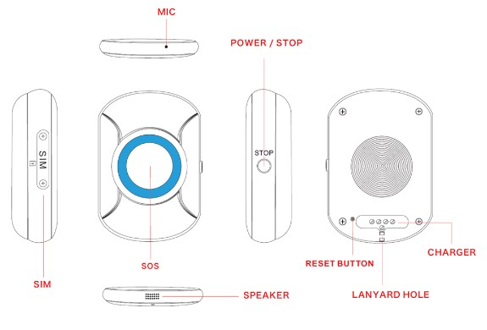
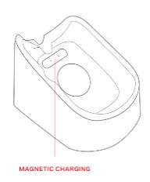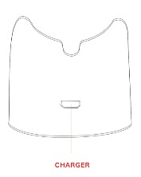

Quick Setup Guide
We recommend a SIM card with a minimum of 500MB of monthly data and unlimited calls/text.
The Safety Pendant requires the Guardian to download the AIBEILE App via the Apple App Store or Google Play Store. This app is required for the user to setup the Safety Pendant and to use its many features.
Before installing the SIM card, ensure the following:
- It is activated and has data enabled and has credit.
- It is not SIM locked with a password.
- It is not locked via PUK Lock.
- It is not damaged and in working order.

Install the SIM Card
- Insert your SIM card into the slot with the gold plates facing upwards with the cornered edge side getting inserted first. Using the SIM pin provided, push the SIM card in until it clicks into place.
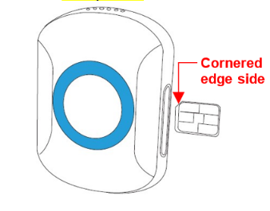
- Place the SIM card cover into the Safety Pendant with the words “SIM” facing upwards, then screw it in with the screws provided.
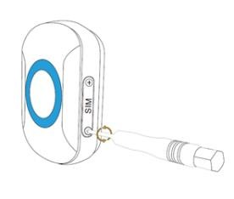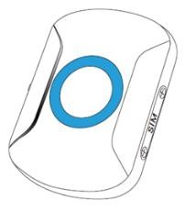

Charging the Safety Pendant
- Charge the Safety Pendant for at least 3hrs prior to its first use.
- Place the Safety Pendant onto the charging cradle making sure the gold plates on the Safety Pendant align to the gold pins on the charging cradle.
- The Safety Pendant will sound “Safety Pendant is charging” when connected to the charger.

Power on /Power off
- Hold down the power button for 3 seconds, the Safety Pendant will vibrate and sound “powering on”.
- Please note: If the Safety Pendant is already on you’ll see the light flash when you press the side button.
- To turn the Safety Pendant off, press the power button 10 times quickly, the Safety Pendant will then sound “powering off”.
Once these steps are complete you can move onto connecting the device to the “AIBEILE APP” and setting up all of it many features.

The AIBEILE App

Downloading AIBEILE App
The AIBEILE App is available to download via the Google Play store and the Apple App store.
Search: AIBELE on the Google Play store or the Apple App store.


IMPORTANT:
YOU MUST TURN ON EACH FEATURE IN THE APP FOR THAT FEATURE TO WORK WITH THE Safety Pendant.
RECOMMENDED FEATURES TO SETUP:
- MEDICINE REMINDERS
- GEOFENCE
- PHONEBOOK/WHITELIST NUMBERS
- SOS CONTACTS
- FALL DETECTOR
- LOW BATTERY ALERT

Registering and pairing the Safety Pendant
Please ensure you have inserted your SIM card, activated your SIM card and turned the Safety Pendant on.
The AIBEILE app will only support 1 device at a time.
The account is only capable of catering a 1:1 relationship with a device. Therefore, if you have multiple devices you will require multiple AIBEILE app accounts

Please ensure you have inserted your SIM card, activated your SIM card and turned the Safety Pendant on.

- Open the “AIBEILE App” and click on “Login by ID (Default option).

- Check the sticker on the back of your device and input the credentials. Your default starting password will be 123456.
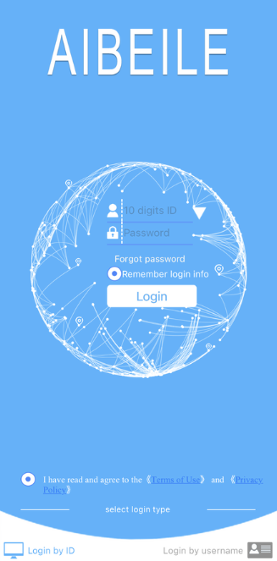

- Once this is done, you will be prompted to change your password to a desired new password via a pop up form as seen below.
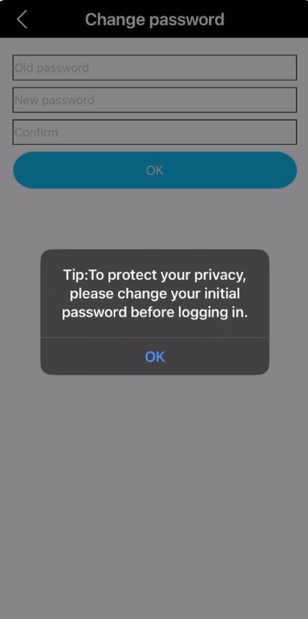

- You’re account is now set up and should now see your GPS location on the map

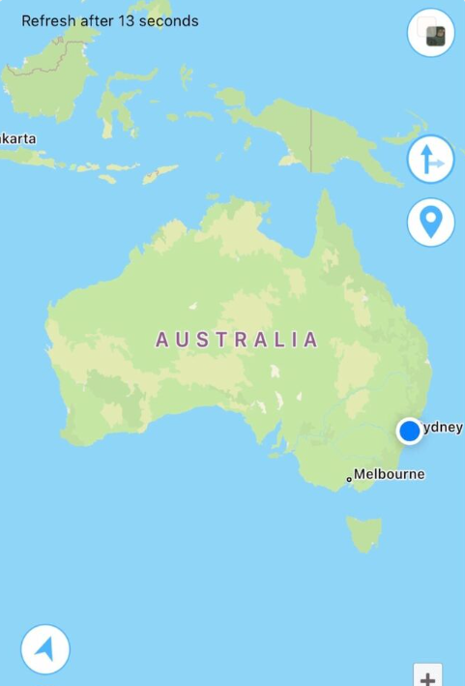

Low Battery Alert
Low battery alerts will allow you as a Guardian to receive notification alerts when the battery on the Safety Pendant becomes low and needs to be charged.
You can turn this feature on or off and adjust at what battery level you would like to receive the notification.
Please note: The low battery alert is only for notifications with the app. The Safety Pendant will always flash twice and vibrate when the battery is at 20% - regardless of the app’s settings.
- Go to the Safety Pendants settings via the “More” icon in the lower right corner of the AIBEILE App’s home page.

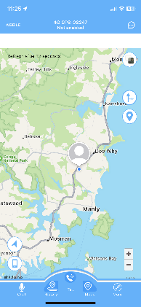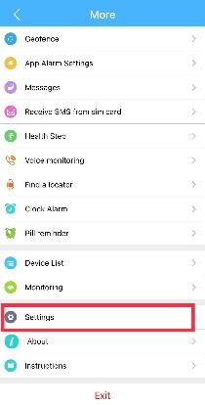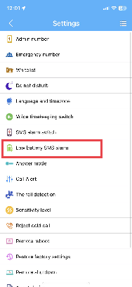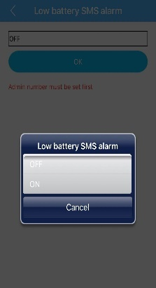

Safety Pendant Settings
Factory Reset
1. Click the “More” icon in the bottom right corner of the AIBEILE Apps Home Page. Then Select “Settings”, Then select “Restore Factory Settings”
PLEASE NOTE: IF YOU FACTORY RESET THE Safety Pendant IT WILL ERASE ALL INFORMATION STORED ON THE DEVICE AND RESET ALL THE SETTINGS IN THE APP. YOU WILL LOSE ALL SAVED SETTINGS AND INFORMATION.

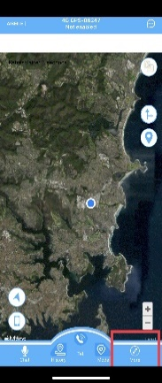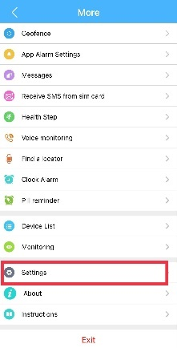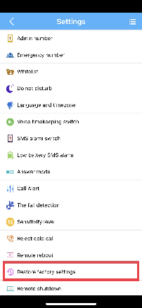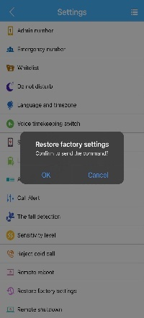

Edit User Profile
In the event that your AIBEILE account needs to be updated or edited please call our support team at 1300 971 584 or email us at help@opelmobile.com.au

Phonebook/Whitelist Numbers
This feature is perfect to restrict unwanted callers contacting the Safety Pendant.
To allow only certain numbers to call the Safety Pendant. Turn whitelist numbers on and add the names and phone numbers that you only want to contact the Safety Pendant by clicking on the “More” icon in the bottom right corner of the App’s Homepage and then selecting “Settings”. You can add up to 15 numbers to the Safety Pendant’s Whitelist.

Pill Reminders
Medicine reminders will help the user remember to take certain medication, or you can create reminders for any task. The Safety Pendant will sound out the recorded voice message to remind the user to complete that task.
- Click on the “More” icon on the AIBEILE apps home page. Click on Add to start a new reminder, write the name of the reminder, choose the frequency and the time, then press sounds button to record the voice message or the text box to add the pill reminder alerts title.
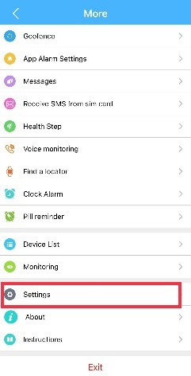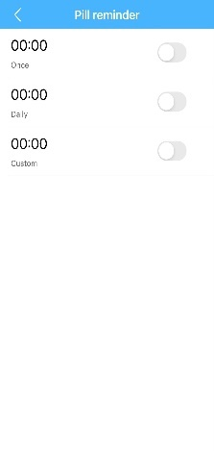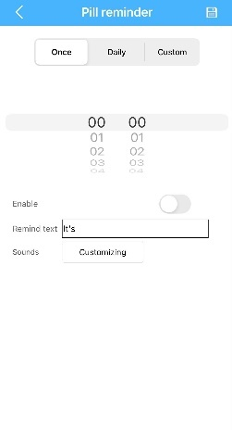

Geofence
You can create safe zones or zones you do not want the user to enter. When you have created these zones on the map you will be notified when they enter or leave these zones.

- Click on Geofence in the Safety Pendant’s settings. Then click on the plus sign on the top right of the page
- When the Map opens – move the pin to where you would like the geofence to start.
- Then adjust the radius to your preferred distance. This can be adjusted up to 5000 metres of the pin.
- You can then add a name to the geofence via the Name bar located at the bottom of the screen and select save.
- You will now be alerted when the device leaves the geofence boundaries.

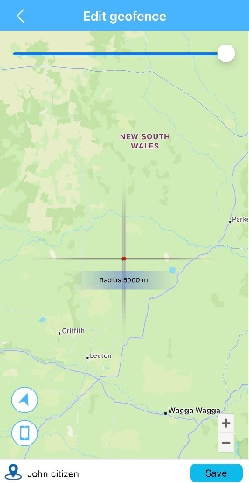

PLEASE NOTE: FOR THE BEST GEOFENCE EXPERIENCE WE RECOMMEND YOU SET GE0FENCE BONDARIES ATLEAST 100M AWAY FROM THE LOCATION YOU ARE WANTING TO SET THE GEOFENCE AROUND, AS THE GPS LOCATION MAY VARY FROM TIME TO TIME DEPENDING ON GPS SIGNAL STRENGTH.
FOR EXAMPLE: A HOME. SET THE BOUNDARY at least 100M AROUND THE HOMES LOCATION.

Emergency Numbers
You can add up to 4 (3+ 1 admin Number) numbers as emergency numbers as SOS contacts. These 4 contacts will be notified when the SOS button is activated, or a Fall Alert has been detected. They will receive a text message with an Alert and the location of the Safety Pendant and will call all of them in order until being answered.
- Click on “More” icon from the AIBEILE home page.
- Then navigate to the settings section
- Select emergency numbers and input the desired contacts
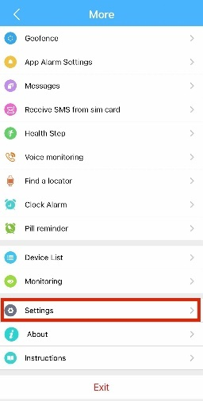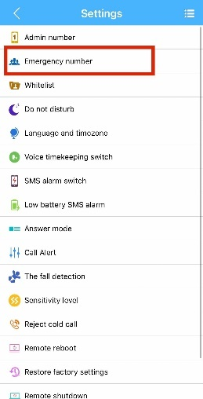

Fall Detector
When Fall Alert is turned on, if the user has a sudden fall the Safety Pendant will automatically detect this fall and activate the SOS feature and alert 4 emergency numbers.
Click on Fall detection in the Safety Pendant’s settings, you can then enable and turn on the fall alert alarm and call features.
Please note: The Fall detector feature is NOT A LIFE SAVING DEVICE and should not be used as one. If you are in a lifethreatening medical emergency, we recommend you call emergency 000 immediately.

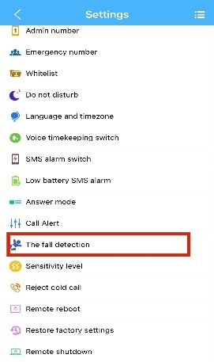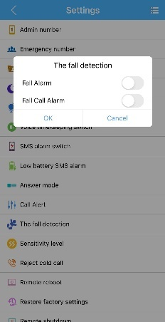

The Safety Pendant

Powering On and Off
To power on the Safety Pendant, hold down the power button for
3 seconds until it vibrates. The Safety Pendant will then sound “powering on” when it has powered on.
To power off the Safety Pendant, press the power button 10 times quickly. The Safety Pendant will then sound “powering off” when the Safety Pendant has powered down.

Charging the Safety Pendant
Ensure when you first unbox the Safety Pendant you charge it for up to 3hrs.
To charge the Safety Pendant, setup the charging cradle and plug the power lead into the wall and turn it on. Place the pendant in the charging cradle, ensuring the gold plates on the Safety Pendant and the charging cradle are aligned.
The Safety Pendant will sound “Safety Pendant is Charging” when connected to the charger.

Answering an incoming call
When a call is incoming, the Safety Pendant will sound “Incoming call alert ... press SOS button to answer.
To answer the incoming call, press the SOS button once. It will then answer the call and you can begin talking to the incoming caller.
To reject the incoming call, press the side power button once. It will then reject that incoming call.

Ending a call
To end a call, press the side power button once. The call will then end.

Activating the SOS Alert
When you need help, press the SOS alert button 3 times within 4 seconds to activate the SOS sequence. The SOS contacts will be sent a text message with your GPS location (If this function is enabled), letting them know you need help. The Safety Pendant will then begin to ring your SOS contacts in sequence order until one of them answers the call. To end the call, press the side power button once.

Stopping SOS Alert
If you accidentally activate the SOS Alert and you wish to stop the SOS sequence, press the side power button once. The Safety Pendant will sound “SOS alert has been stopped”, the Safety Pendant will then stop the SOS sequence.

Fall Detection Alert
If you have a sudden fall, the Safety Pendant will automatically start the SOS Alert sequence (If this function is enabled). The SOS contacts will be sent a text message with your GPS location (If this function is enabled), letting them know you need help. The Safety Pendant will then begin to ring your SOS contacts in sequence order until one of them answers the call. To end the call, press the side power button once.

Stopping Fall Detection Alert
If the fall alert is activated accidentally, you can press the side power button once to end the fall alert sequence.

Low Battery Alert
Your Safety Pendant will Vibrate and Flash when your battery percentage reaches 20%. The light will then aluminate every 3mins until the Safety Pendant is placed back on charge. Please ensure you then recharge your Safety Pendant immediately when you see this alert to ensure it is always active. We recommend you charge your Safety Pendant overnight daily.

Using the Safety Pendant in water
Your Safety Pendant is IP67 rated, which means you can submerge the pendant in up to 1 metre of deep freshwater for no longer than 30mins. In the case of showering and bathing in baths we recommend you use the water resistance bag which is included in the giftbox otherwise the detergents can compromise the pendant. Do not submerge the Safety Pendant in saltwater or chlorine. The Safety Pendant is not designed to withstand these types of water and soap elements.

Using the included accessories
Your Safety Pendant comes with accessories to help you use it.
- The Lanyard can be used to hang the Safety Pendant around your neck.
(Not recommended for people with a pacemaker)
(Not recommended to be worn around your neck while sleeping)
- The Belt Clip Pouch is perfect to secure the Safety Pendant on a belt or an item of clothing.
- The Water-Resistant Pouch is designed to be used for when showering, bathing in baths or spas, swimming in salt/Chlorine pools or oceans to further protect your pendant. Ensure you close both seals of the pouch to ensure water resistant tightness.
- The Charging cradle is designed for ease of charging. Place your Safety Pendant on the charging cradle to charge.

Troubleshooting and Support
If you are experiencing difficulties with your Safety Pendant or the AIBEILE app, please go through the following troubleshoots:

The Safety Pendant will not power on
- Ensure you are pressing and holding the power button for 3 seconds to turn it on.
- Ensure you have charged it for at least 3hrs.
- Using the small pin provided, press the "Reset" hole on the back of the device.

Battery is draining quickly
- Ensure you charge your device for at least 3hrs so it is fully charged.
- Check the signal strength in your area as if your location has a low signal strength the devices battery will drain faster.

No network connection
- Ensure you have inserted the SIM card correctly and are using the correct size SIM card. Follow instructions in the quick set up guide for installing the SIM card.
- Your SIM card may be damaged or dirty. Ensure you replace your SIM with your network provider if this error occurs.
- Ensure you have a data activated and credit on your SIM Card.
- Your network signal may be weak or out of range. Contact your network provider or try the Safety Pendant in a different location to check your signal.
- After the Pendant is switched on, press the power button once to check the device status. 1 x LED means connected to the network; 3 x LED means no connection to the network.
- Ensure no SIM PIN is setup on the SIM card.
- Disable whitelist within the app.

Cannot receive calls
- Ensure your Safety Pendant is switched on.
- Ensure you have enough signal strength to receive calls.
- Ensure your SIM card is installed correctly.

Safety Pendant won’t charge
- Ensure the power plug is inserted in the wall socket correctly and the wall switch is turned on.
- Ensure the wall power socket is working by testing another device or a separate power socket.
- Ensure you have inserted the micro-USB cord into the charging cradle.
- Ensure you have left the Safety Pendant on charge for at least 3hrs as the battery may have run out of charge completely.

Fall detection activates accidentally or won’t activate
- Change the fall detection sensitivity level in the app to either low for low sensitivity or high for high sensitivity.
- Ensure you have the Fall Detection enabled

App is displaying the wrong GPS location
Important: If your Safety Pendant is unable to pick up a GPS signal it will use the Cellular towers to pinpoint your approximate location, this means you will not get a precise location just an approximate location between the cellular towers.
- Close the app completely and restart your mobile phone and re-open the app.
- Restart the Safety Pendant.
- Logout of the App and re-login.
- Ensure the Safety Pendant is turned on and has good network signal.
- Test the Safety Pendant in a different location and in an outdoor environment.
- Factory Reset the Safety Pendant via the app.

Not receiving app Notifications
- Ensure your app settings are set to receive push notifications.
- Close the app completely and restart your mobile phone and re-open the app.
- Restart the Safety Pendant.
- Logout of the App and re-login.

